Experiment worksheet

4.1 The properties of matter can be described

Pages 62–63 and 178

Experiment 4.1: Comparing states of matter

Aim

To investigate the characteristics of solids, liquids and gases.

Materials

• Clamp

• 250 mL beaker

• Water

• Food colouring

• Three different shaped containers

• Plastic syringe

• Stopper to fit syringe

• 100 mL beaker

• Electronic balance

• Balloon

Method

1 Copy Table 1 and complete it as you work through the method.

2 Examine the clamp and record its mass, shape, ability to be compressed and other data in the table.

3 One-third fill the 250 mL beaker with water. Add two drops of food colouring and mix carefully.

4 Pour the coloured water, in turn, into the three other containers. Record what happens to the shape of the water in each of the containers.

5 Half fill the syringe with water and invert it onto the stopper on the bench as shown in Figure 1. Make sure that the syringe is well sealed before compressing it. Record whether water can be compressed (i.e. made to take up less volume).

6 Set the empty 100 mL beaker on the electronic balance and press the TARE button. Pour in the water from the syringe and measure the mass of the water.

7 Draw the syringe full of air and invert the syringe onto the stopper. Compress the syringe. Record whether air is compressible and takes the shape of the syringe.

8 Record the mass of the empty balloon and then blow it up. Tie off the end and weigh the balloon again, this time with air in it. Subtract the mass of the empty balloon from that of the blown-up balloon to calculate the mass of the air inside the balloon. Record whether the air takes the shape of the balloon.

Results

Complete Table 1.

Table 1

|  |  |  |  |  |  |
| --- | --- | --- | --- | --- | --- |
| Matter | State of matter | Mass (g) | Able to take shape of container? | Able to be compressed? | Other characteristics observed |
| Clamp | Solid |  |  |  |  |
| Water | Liquid |  |  |  |  |
| Air | Gas |  |  |  |  |

Discussion

1 Which substances had a measurable mass?

2 Did each substance take up space? Was there any variation in the shapes each substance was able to take?

3 Which states of matter took on the shape of their containers?

4 Which state of matter can be compressed into a smaller space? Describe what happened.

Conclusion

Write a short paragraph to describe what you know about the states of matter.

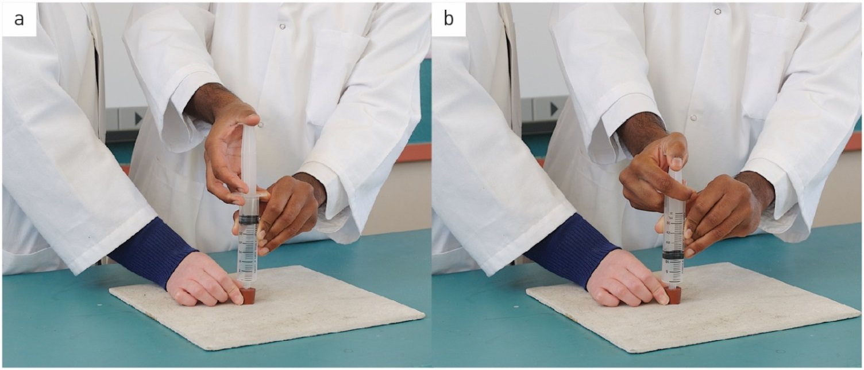

Figure 1 Testing the compressibility of air: (a) before and (b) after depressing the plunger on the syringe

Experiment worksheet

4.3 The particle model explains matter

Pages 66–67 and 179

Challenge 4.3A: Modelling matter

By now you should have a good idea about how the particle model of matter describes the structure of solids, liquids and gases.

What you need

• Items such as table tennis balls, coins, lollies, marbles and pieces of modelling clay

What to do

Make a model of the three states of matter, using objects to represent the particles. Suitable items include table tennis balls, coins, lollies, marbles and pieces of modelling clay. Alternatively, you can use objects from home.

Discussion

1 How well do your particles represent the characteristics of real particles?

2 How well does your model represent the position and arrangement of real particles?

3 Can your model represent the movement of real particles?

4 How well could your model help explain the properties of real substances, such as the melting of solids?

5 Is there a better material (or different objects) that you could use to represent the particles? How would this improve the model?

Experiment worksheet

4.3 The particle model explains matter

Pages 66–67 and 179

Challenge 4.3B: Making a cuppa

You can observe diffusion in a simple experiment.

What you need

• Two large beakers

• Hot water

• Cold water

• Two tea bags

What to do

1 Fill one beaker with hot water and the other with cold water

2 Allow the beakers to sit still for a few minutes so that the movement of the water inside them is reduced.

3 Place a tea bag into each beaker. Brown colour from the tea leaves seeps into the water and then diffuses throughout the beaker of water.

4 Compare the speed of diffusion in hot and cold water.

Experiment worksheet

4.4 The particle model can explain the properties of matter

Experiment 4.4: The density den

Pages 68–69 and 180–181

To calculate the density of a substance, you first need to know its mass and volume. The most appropriate units for the substances you will be working with are grams (g) for mass and millilitres (mL) or cubic centimetres (cm3) for volume. Millilitres tend to be used for the volume of liquids, whereas cubic centimetres are used for solids.

Note that 1 mL is the same as 1 cm3. Therefore, grams per millilitre (g/mL) is the same as grams per cubic centimetre (g/cm3).

Three density experiments are set up around the laboratory. In two experiments, you will measure density in grams per millilitre (g/mL) to make it easier to work with liquids.

STATION A

Aim

To measure the density of liquid water.

Materials

• 10 mL measuring cylinder

• Electronic balance

• Water

• Calculator

• 50 mL measuring cylinder

Method

1 Use Table 1 and use it to record your measurements.

2 Measure the mass of the 10 mL measuring cylinder. Record its mass in grams.

3 Remove the measuring cylinder from the balance and add 6.0 mL of water to it.

4 Measure the mass of the cylinder and water. Calculate the mass of the water by subtracting the mass of the cylinder from the combined mass of the cylinder and water.

5 Calculate the density of the water and record your answer. (Don’t forget the units!)

6 Repeat the experiment with the 50 mL measuring cylinder and 20 mL of water. Calculate the density of the water.

7 To obtain a third measurement of the density of water, choose one of the two measuring cylinders and any amount of water. Measure the mass of the water and its volume. Calculate the density of the water.

Table 1

|  |  |  |  |  |  |
| --- | --- | --- | --- | --- | --- |
|  | Mass of measuring cylinder (g) | Volume of water (mL) | Mass of measuring cylinder and water (g) | Mass of water (g) | Density of water  =mass/volume (g/mL) |
| 10 mL measuring cylinder |  |  |  |  |  |
| 50mL measuring cylinder |  |  |  |  |  |
|  |  |  |  |  |  |
|  |  |  |  |  | Average= |

Results

List the three results you obtained for the density of water. Calculate an average value.

Discussion

1 The standard value for the density of water is 1.00 g/mL at 25°C. How does your average value compare with this?

2 What could have caused your results to differ from the standard value of the density of water?

3 When you calculate the density of water, does the amount of water used make any difference? Explain the reasons for your answer.

4 Why do scientists repeat experiments?

STATION B

Aim

To measure the density of regular-shaped blocks made from different materials.

Materials

• Several blocks made from different substances (e.g. wood, polystyrene, lead, zinc)

• Ruler

• Electronic balance

• Calculator

Method

1 Finish Table 2, adding a row for each additional substance, and measure and record the mass of each of the blocks.

2 Calculate the volume of each block. (An example has been done for you in Figure 1)

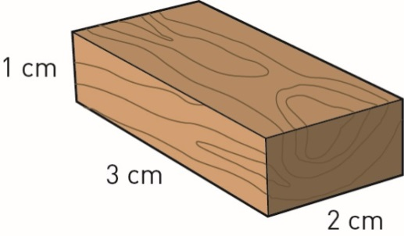

Figure 1 Calculating the volume of a regular-shaped block.

Table 2

|  |  |  |  |  |  |  |
| --- | --- | --- | --- | --- | --- | --- |
| Substance | Length (cm) | Width (cm) | Height (cm) | Volume (cm3) | Mass (g) | Denisty (g/cm3) |
| Wood | 3 | 2 | 1 | 3 x 2 x1 = 6 | 3 | 3 ÷ 6 = 0.5g/cm3 |
|  |  |  |  |  |  |  |
|  |  |  |  |  |  |  |
|  |  |  |  |  |  |  |
|  |  |  |  |  |  |  |

Results

Rank the blocks in order from least dense to most dense.

STATION C

Aim

To measure the density of irregularly shaped objects.

Materials

• Four different objects (e.g. spatula, a small rock, a lump of plasticine and an object of your choice) that each fit into measuring cylinder

• Electronic balance

• 100 mL measuring cylinder

Method

1 Complete Table 3 with four blank rows.

2 Measure the mass of the first object. Record the mass, in grams, in your table.

3 Use the displacement method to work out the volume of the object. Approximately half fill the measuring cylinder. To calculate the volume of the object, subtract the volume of water in the cylinder before the object was added from the volume after the object was added.

4 Calculate the density of the object.

5 Repeat the experiment with the remaining objects.

Results

Table 3

|  |  |  |  |  |  |
| --- | --- | --- | --- | --- | --- |
| Object | Mass (g) | Volume before (mL) | Volume after (mL) | Volume of object (after – before, In Ml) | Density (g/mL) |
|  |  |  |  |  |  |
|  |  |  |  |  |  |
|  |  |  |  |  |  |
|  |  |  |  |  |  |

Discussion

1 Why is water used to measure density in this experiment? Could another liquid be used? Give reasons for your choice.

2 What were some of the difficulties you had using the displacement method for calculating density?

3 What were some advantages of using the displacement method for measuring volume?

4 How does the density of water compare with those of the other objects you measured? Use the results from all the experiments to rank the objects from lowest to highest density.

5 How would our world be different if the density of water was five times as much (i.e. 5 g/mL)? How would this affect your mass, your life and the world generally?

Conclusion

What do you know about how density affects the behaviour of objects?

Experiment worksheet

4.5 Increasing kinetic energy in matter causes it to expand

Experiment 4.5B: From ice to steam

Pages 70–71 and 184

Aim

To investigate the melting and boiling points of water.

Materials

• 250 mL beaker

• Crushed ice

• Water

• Tripod stand

• Bunsen burner and heating mat

• Gauze mat

• Stirring rod

• Watch or clock

• Retort stand, clamp and boss head

• Thermometer (0–110°C) or thermistor probe

Safety

• Steam and boiling water can both scald. Take great care when measuring the higher temperatures. If scalded, place the area of skin under cold running water for at least 5 minutes and show your teacher.

**CAUTION!** WEAR SAFETY GLASSES AND LAB COAT, AND TIE LONG HAIR BACK, WHEN USING A BUNSEN BURNER.

Method

1 Place some ice and water into the beaker.

2 Wait until most of the ice has melted.

3 While you are waiting, prepare a tripod stand, Bunsen burner, heating mat and other equipment so you can heat the water in the beaker. Set up a clamp to hold a thermometer or a thermistor probe that is connected to a data logger.

4 Complete the following table.

|  |  |
| --- | --- |
| Time (Minutes) | Temperature (°C) |
| 0 |  |
| 1 |  |
| 2 |  |
| 3 |  |
| 4 |  |
| 5 |  |

1 Place some crushed ice and a small amount of tap water in the beaker. Stir with the stirring rod for approximately 1 minute.

2 Measure and record the temperature of the water and ice mixture. This is the melting point of water. Record the temperature in your table at time 0.

3 Set up the equipment as shown in Figure 1, checking to make sure the thermometer is not touching the bottom of the beaker and that it is secure in the clamp. Do not stir with the thermometer.

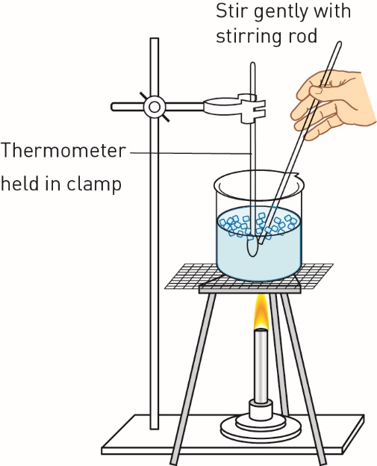

Figure 1 Experimental set-up for measuring the melting point of ice.

1 Light the Bunsen burner and start heating the ice and water.

2 Measure and record the temperature of the mixture in the beaker every minute until the water starts to boil and produce steam. This is the boiling point of water.

3 Continue heating for another 4 minutes, unless most of the water has evaporated.

4 Using graph paper, or a suitable computer program, draw an appropriate graph with temperature on the vertical axis and time on the horizontal axis.

Results

Record your observations, including your table and graphs.

Discussion

1

a At what temperature did you measure the melting point of ice?

b How does your measured melting point of ice compare with the standard measurement of 0°C?

2

a At what temperature did you measure the boiling point of water?

b How does your measured boiling point of water compare with the standard measurement of 100°C?

3 Were there times when it was difficult to read the thermometer? Why?

4 Compare your results with those of the rest of the class. Suggest why there is a variation in the answers.

Conclusion

What do you know about the melting and boiling points of water?

Experiment worksheet

4.5 Increasing kinetic energy in matter causes it to expand

Experiment 4.5A: Effect of heat

Pages 70–71 and 182–183

Aim

Three activities are set up to determine the effect of heat on solids, liquids and gases.

**CAUTION!** WEAR SAFETY GLASSES AND A LAB COAT, AND TIE LONG HAIR BACK, WHEN USING A BUNSEN BURNER.

STATION 1: HEATING A SOLID

Materials

• Ball and ring apparatus

• 2 × 250 mL beakers

• Hot tap water

• Ice

Method

1 Look at your ball and ring. Try passing the ball through the ring before heating and cooling. Record your observations.

2 Half fill a 250 mL beaker with hot tap water. Place your ball in the hot water for minutes. Keep the ring away from the hot water.

3 Try passing the ball through the ring. Record your observations.

4 Half fill the other beaker with cold tap water and add ice. Put the ball in the iced water and leave it for 5 minutes. Keep the ring away from the iced water.

5 Try passing the ball through the ring. Record your observations.

Results

Record your observations.

Discussion

1 What happened to change the size of the metal ball?

2 Use the kinetic theory of matter to explain what was happening to the particles in the solid when heat was applied.

3 Do objects return to their original size when they cool to their original temperature?

STATION 2: HEATING A LIQUID

Materials

• 100 mL conical flask

• Narrow glass tubing

• Rubber stopper to fit tubing

• Food colouring

• Water

• Felt-tipped pen

• Bunsen burner and heating mat

• Gauze mat

• Tripod

Safety

• Make sure the apparatus is not left unattended. The dye and water will spurt out the top of the glass tube if allowed to.

• The flask and its contents may be hot. Allow all equipment time to cool before handling it.

Method

1 Put two drops of food colouring in the flask and fill the flask right to the top with water.

2 Place the stopper fitted with the tube in the flask. Some water will rise up the tube. Using the felt-tipped pen, mark this first level on the tube.

3 Place the flask on the gauze mat on the tripod and heat gently.

4 After a few minutes of heating, turn off the Bunsen burner. Mark the level of the water in the tube again.

5 Watch what happens to the level of the water as it cools.

Results

Record your observations.

Discussion

1 Describe what happened to the water in the tube as the flask was heated.

2 What happened to the level of the water in the tube as the water cooled?

3 Use the kinetic theory of matter to explain why the liquid expanded when heated.

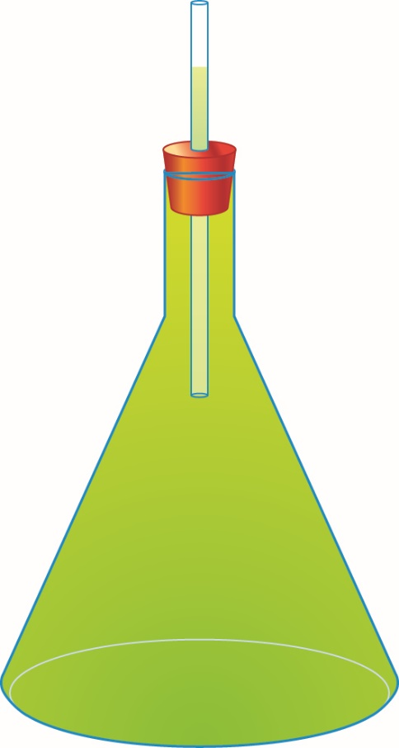

Figure 1 Experimental set-up to show the expansion of a liquid on heating

STATION 3: HEATING GASES

Materials

• Balloon

• 100 mL conical flask

• String

• Ruler

• 250 mL beaker of hot water

• Ice bath (250 mL beaker of water and ice)

Method

1 Blow up the balloon to help stretch the rubber. Let the air out again until it is about the size of an apple.

2 Place the balloon over the neck of the flask.

3 Use the string and ruler to measure the circumference of the balloon at room temperature. Complete the following table and record this measurement.

|  |  |
| --- | --- |
|  |  |
|  |  |
|  |  |
|  |  |

4 Place the flask with the balloon in a beaker of hot water. Wait a few minutes.

5 Measure and record the balloon’s circumference.

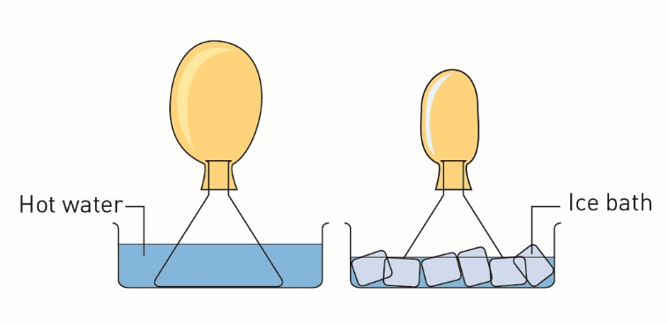

Figure 2Experimental set-up to show the expansion and contraction of a gas after heating and cooling.

6 Place the flask with the balloon in an ice bath with a small amount of water. Wait a few minutes and then measure and record the balloon’s circumference.

Results

Record your observations.

Discussion

1 What happened to the size of the balloon as the temperature went from cold to hot?

2 Was any air added to change the size of the balloon?

3 Use the ideas of the particle model of matter to explain how the balloon expanded and contracted with the changes in temperature.

Conclusion

What do you know about the effects of heat on solids, liquids and gases?

Experiment worksheet

4.6 Atoms and elements make up matter

Challenge 4.6A: Classifying elements

Pages 72–73 and 185

What you need

• Cardboard

• Felt-tipped pens

• Scissors

What to do

1 Make up some cards like the ones shown in Figure 1 to represent the different elements.

2 Sort the cards into those with a one-letter symbol and those with a two-letter symbol.

• How many elements have a one-letter symbol?

• How many have a two-letter symbol?

• Why is classifying elements according to their symbol a bad idea?

3 Sort the cards according to the colour of the element.

• How many elements are silver coloured?

• How many elements have another colour?

• Why is classifying elements according to their colour a bad idea?

4 Sort the cards according to whether they are solids, liquids or gases.

• How many elements are solids, liquids and gases?

• Why is classifying elements according to their state a bad idea?

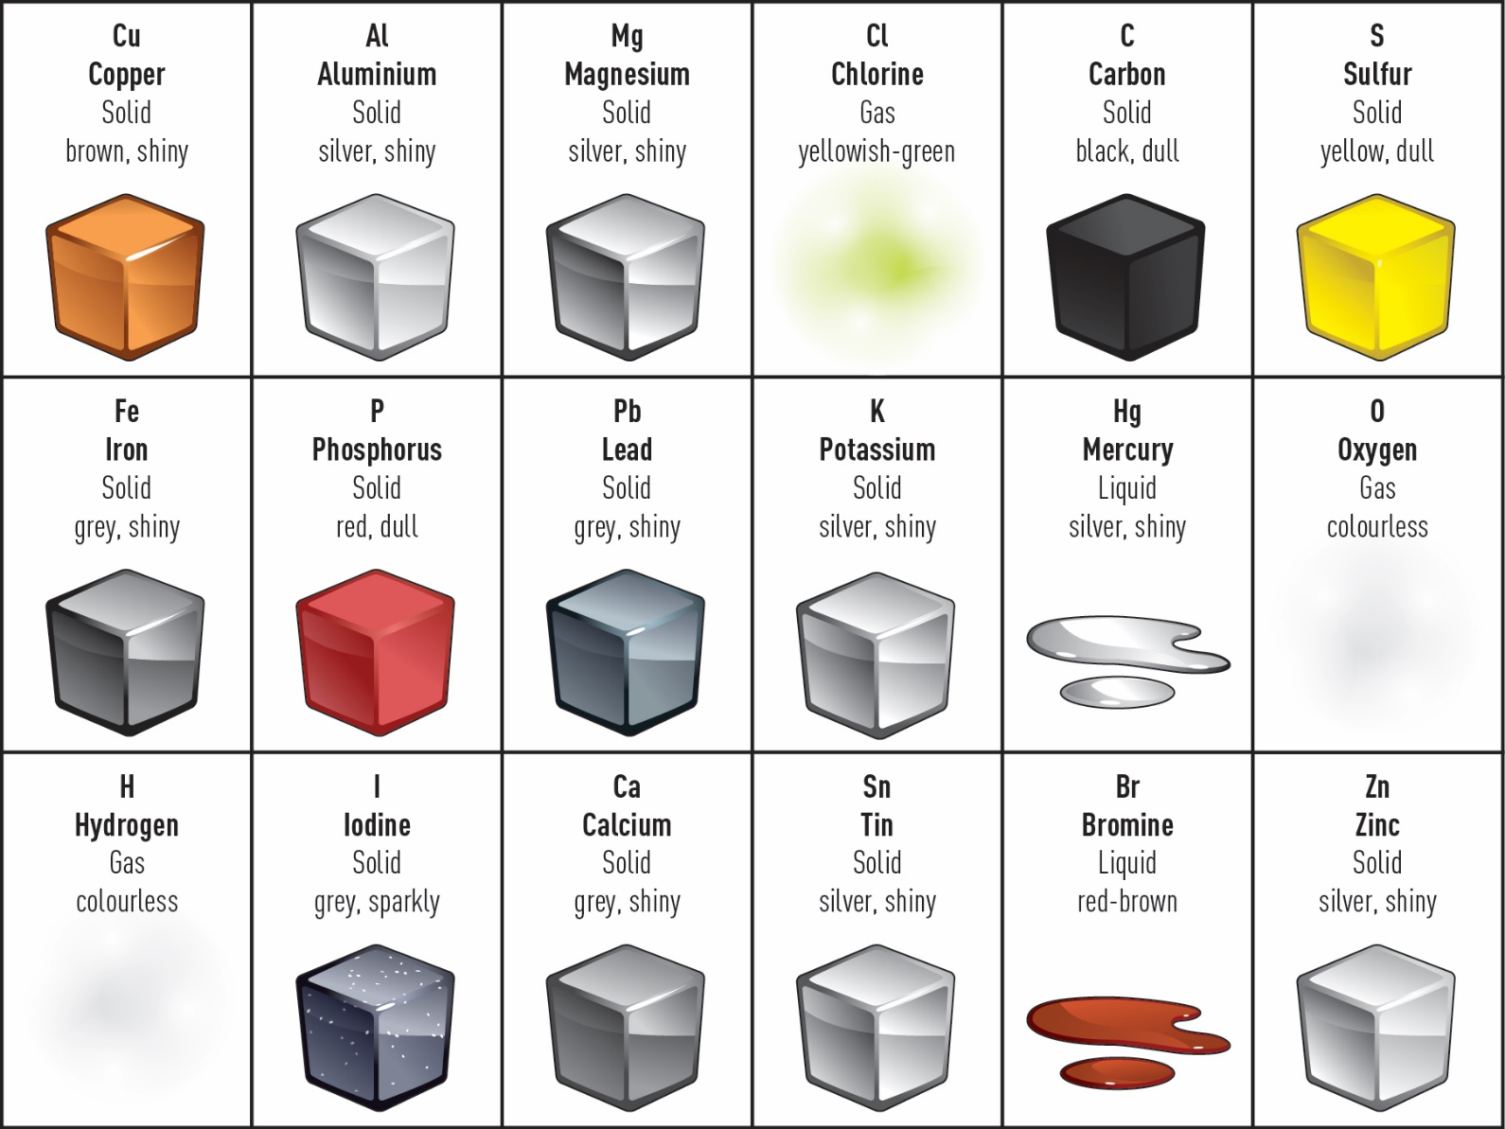

Figure 1Example element cards.

Experiment worksheet

4.6 Atoms and elements make up matter

Experiment 4.6: Properties of the elements

Pages 72–73 and 187

Aim

To observe the differences between different elements of the periodic table.

Materials

• Steel wool

• Aluminium

• Copper

• Magnesium

• Graphite/lead pencil

• Zinc

• Iron nail (nongalvanised)

• Forceps

• Battery

• 3 wires

• Lamp

• 0.5 M hydrochloric acid

• Distilled water

• 6 test tubes

• Test tube holder

Method

1 Use the steel wool to rub a small section of your material. Record the colour and appearance in Table 1. Is it shiny or dull?

2 Use the forceps to try to bend each substance. Is it malleable (able to bend)? Is it brittle (breaks when bent)?

3 Set up a circuit with the battery, lamp and wires as shown below. Connect the two loose wires to the material. Does the light glow? Does your material conduct electricity?

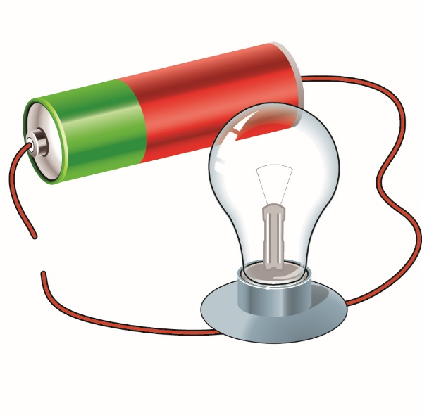

Figure 1 This incomplete circuit can measure the conductivity of objects.

Replace your sample into the test tube and add 3 cm of hydrochloric acid to the test tube. Do you see any immediate reaction? If possible, leave it overnight to see if there is any change.

Repeat your tests with all of your samples and record your observations in Table 1.

Results

Table 1

|  |  |  |  |  |
| --- | --- | --- | --- | --- |
| **Element** | **Is it shiny/dull?** | **Is it malleable/ Brittle?** | **Does it conduct electricity?** | **Does it react with acid?** |
|  |  |  |  |  |
|  |  |  |  |  |
|  |  |  |  |  |
|  |  |  |  |  |

Discussion

1 What similarities do you observe between the elements you tested?

2 Can you divide all the materials into two groups? What properties do you use to separate the materials?

3 If you discovered a new material that was shiny and that bent when you dropped it, which groups would you put it in? Explain. What other properties might you expect it to have?

Conclusion

Describe what you know about the physical and chemical properties of these materials.

Experiment worksheet

4.7 Atoms bond together to make molecules and compounds

Experiment 4.7: Decomposing copper carbonate

Pages 74–75 and 188

Aim

To decompose (break into smaller parts) copper carbonate.

Materials

• Plastic beaker

• Test tube or crucible

• Electronic balance

• Spatula

• Copper carbonate

• Bunsen burner and heating mat

• Tripod stand

• Matches

• Wooden tongs

• Paper towel

Safety

**CAUTION!** WEAR SAFETY GLASSES AND LAB COAT, AND TIE LONG HAIR BACK, WHEN USING A BUNSEN BURNER.

• Use a yellow (cooler) safety flame for this experiment.

• Hold the test tube or crucible securely with the tongs and always point it away from yourself and others.

• Never place hot objects on the balance.

Method

1 Place a plastic beaker containing the test tube on the balance. Tare the balance so it reads zero.

2 Using a spatula, add approximately 3 grams of copper carbonate into the test tube. Record the mass in grams (this is W1).

3 Set the Bunsen burner up on the heating mat. Light the flame, ensuring the hole is closed and a yellow (safety) flame is burning.

4 Using the wooden tongs to hold the top of the test tube, gently wave the base of the test tube over the flame twice. Record any changes. Continue to do this for 2 minutes, recording any changes. Be very careful to point the open end of the test tube away from others and yourself.

5 Allow the test tube and copper carbonate to cool. Wipe any black powder from the outside of the tube off with paper towel.

6 Place the test tube in the original plastic beaker. Reweigh the test tube and beaker and record the mass in grams (this is W2). Note any change in weight.

Results

Record your results in Table 1.

Table 1

|  |  |  |
| --- | --- | --- |
| Weight of copper carbonate before heating (W1) (g) | Weight of copper carbonate after heating (W2) (g) | Difference W1-W2 (g) |
|  |  |  |

Discussion

1 What happened to the copper carbonate? Consider the colour and any change in mass.

2 What evidence is there that copper carbonate is a compound and not an element?

3 What are the possible sources of error in this experiment?

Conclusion

What happens when copper carbonate decomposes?